CANDIDATE BRIEF

……………..

Cricket development officer- Disability (Super 1’s)
December 2019

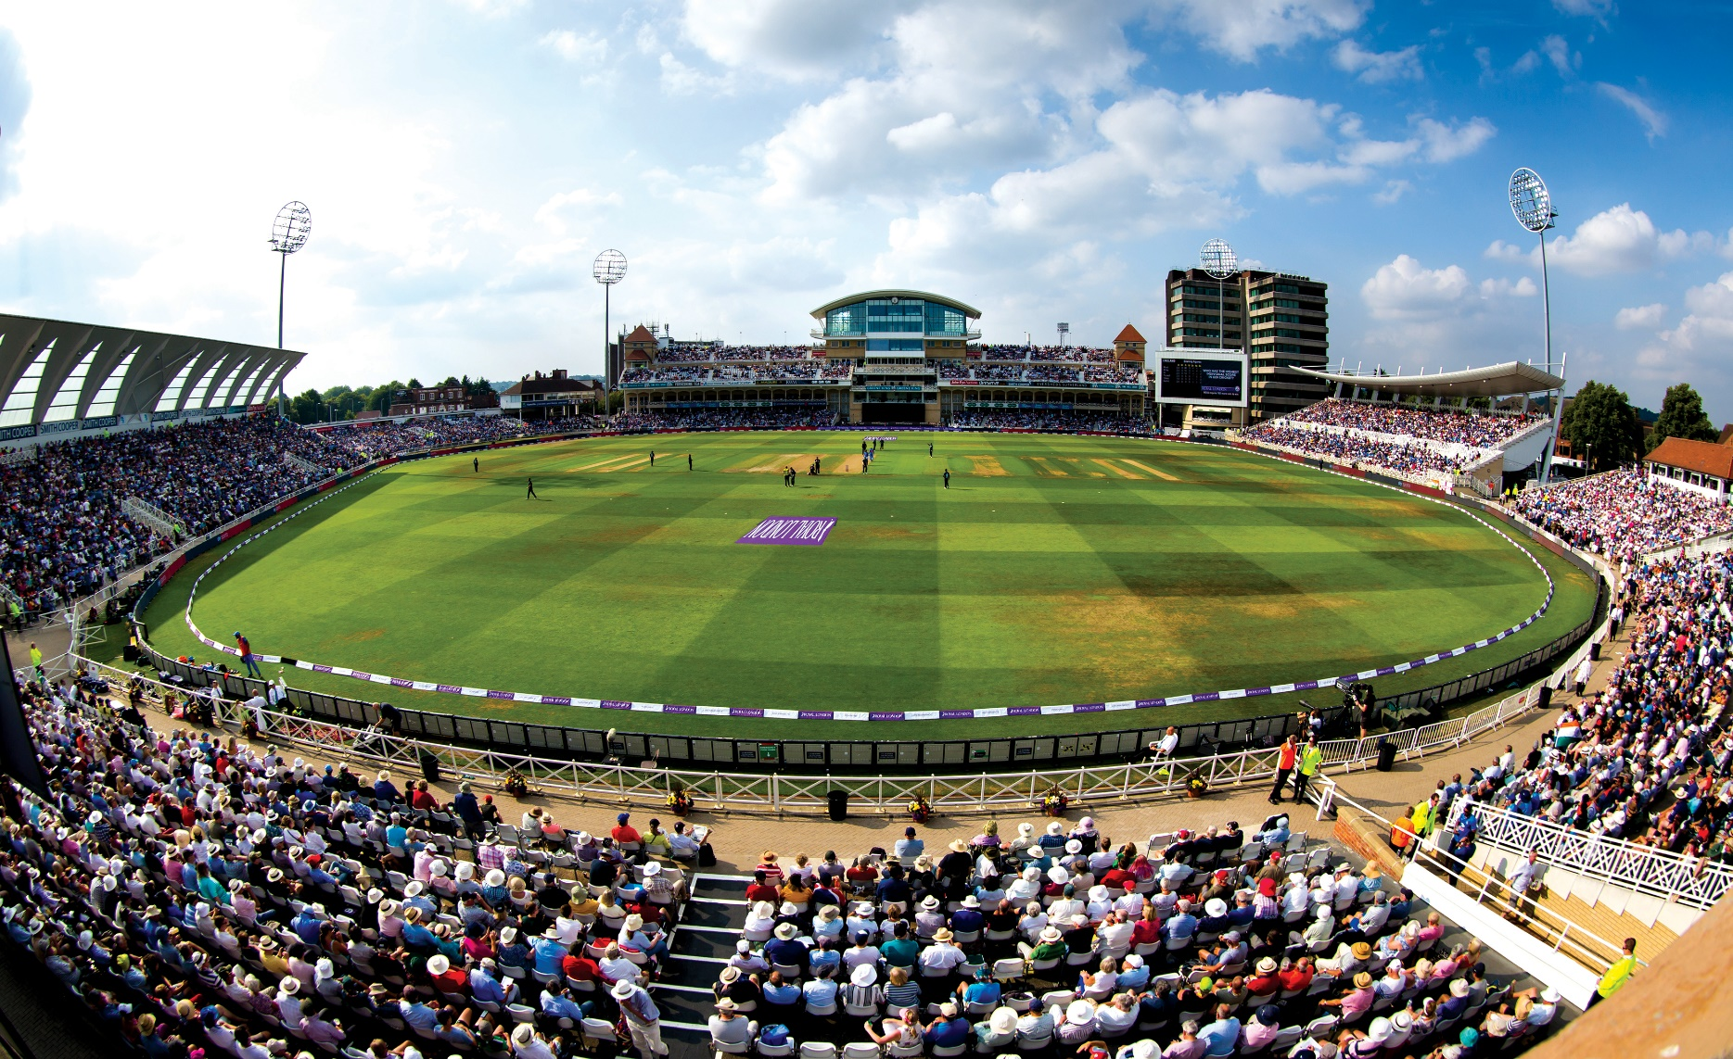

Nottinghamshire County Cricket Club, in partnership with the Lord’s Taverners, wish to appoint a Disability Development Officer to deliver the new and exciting Super 1s programme across Nottinghamshire. The officer will provide community based cricketing opportunities, both competitive and coaching, for young people with disabilities. The Development Officer will use the power of cricket as a tool for change; increasing confidence, communication, leadership and independence in the participants.

This new and exciting role seeks an energetic and enthusiastic individual who has a passion for supporting and developing young people, and working with multiple partners and organizations. The role combines coaching and development work and will be responsible for engaging young disabled people across Nottinghamshire into becoming active members of new community based Super 1’s disability cricket hubs. These hubs will engage in a programme wide competition and provide a sense of belonging and community amongst its participants. Using cricket as a tool for engagement, these community hubs will provide personal development opportunities to young disabled people through Sports Leaders, informal learning and other cricketing and non-cricketing opportunities.

CRICKET DEVELOPMENT OFFICER- DISABILITY (SUPER 1’S)

- Fixed Term (2 years)
- Full-time
- Salary £20,000 per annum

REPORTING TO: Community & Development Manager

SPECIFIC ROLE PROFILE
The focus of this role is to deliver the aims and outcomes of the Super 1’s programme which are:
- Create community led disability cricket hub environments, that operate all year round, and that offer both participation and competitive opportunities
- Develop initiatives that increase confidence, communication, leadership and independence. Ensure participants personal growth can develop beyond cricket
- To support the delivery of the Lord’s Taverners Table Cricket programme.

The needs of this role are:
- Plan, deliver and review the Super 1s disability community hubs that are aligned to the needs of the local people
- Successfully engage young disabled people aged 12-25 years old into a community based hub
- Deliver a year-round cricket ‘coaching’ programme that is diverse, inclusive and is open to young people with a disability from the community
- Develop cricket opportunities for all players of all standards (coaching, tournaments, teams or casual play)
- Deliver a year-round competition that engage all disability community hubs in a minimum of 4 competition days and a final
- Create a sustainable pathway for higher ability players through increased Super 9s and County squad provision.
- Develop partnerships with external organisations and stakeholders resulting in an enhancement of the cricket development plan
- Coordinate the delivery of lifestyle workshops to each hub.
- Manage and run monitoring and evaluation of the programme through the provided online system
- Develop relationships with schools and deliver taster sessions to help signpost young people to super 1 hubs.
- Maintain regular communication and dialogue, whilst also capturing feedback, opinion and a review of satisfaction
- Provide formal written reports and case studies, and ensure that all monitoring and evaluation is undertaken as required
- Work closely with existing cricket clubs to engage with and signpost disabled people where possible
- Engage and support the development of the wider pool of volunteers and sports coaches by mentoring and / or signposting for opportunities both formally and informally to aid delivery.
- Ensure the branding and identity of the programme within delivery
- Organise and deliver launch events to raise awareness of the programme
- Increase awareness of the Super 1s programme locally
- Work closely with all other aspects of Nottinghamshire County Cricket Club.

The successful post holder will be:
- Committed to improving the lives of young people
- Committed to their own personal professional development and play an active role in the professional development of your colleagues
- ECB DBS checked (enhanced level)
- Represent the Lord’s Taverners and Nottinghamshire Cricket Board in a positive and professional manner at all times
- Ensure the health, safety and welfare of yourself, participants and others at all times
- Conduct sessions in accordance with the appropriate ECB guidelines and good practice
- Take part in other activities as and when required
- Perform all duties in an equitable manner and to actively promote the principles of equality amongst colleagues, partners and service users

KEY PERFORMANCE INDICATORS (Year 1)

- To establish 4 Community Hubs geographically spread across Nottinghamshire.
- Deliver 4 tasters sessions to promote each of the community hubs.
- Deliver 35 weeks of 1hour coaching sessions at each community hub site.
- Recruit and retain a minimum of 10 participants at each community hub site.
- Provide 5 days of holiday provision for each community hub site.
- Provide a minimum of 1 competitive opportunity for each community hub site that leads into a county final.
- Run a Young Leaders Course targeting a minimum of 5 participants at each community hub and actively engage them in the sessions as leaders.
- Deliver 1 Lifestyle workshop to each community hub site to all participants.

PERSON SPECIFICATION

 | Essential | Desirable
Experience | - Experience of working with people with disabilities  - Experience of delivering community development programmes  - Experience of working within Sports Development with recreational sports clubs and the enthusing of volunteers  - Experience of partnership working and the ability to create strong and sustainable links  - Experience of working in both school and community settings  - Experience of monitoring and evaluating the impact of sessions and programmes  - Experience of teaching/coaching children of all ages | - Experience of managing a cricket coaching programme.  - Experience of working with inactive people in recreational sport and/or physical activity sessions  - Experience of mentoring, supporting and encouraging volunteers  - Experience of working on cricket specific projects
Knowledge | - Understanding of disability. | - Understanding and experience of a variety of Cricket Development programmes.
Skills | - Good project management skills and ability to prioritise and work to deadlines  - Excellent customer service skills, with the ability to build relationships and communicate effectively with a diverse range of people.  - Effective communicator and the ability to engage with people of all levels, especially parents of participants.  - Excellent leadership skills  - Excellent administrative skills and evidence of project work  - Computer literate and effective user of Word, Excel, Outlook and other Microsoft programmes.
Qualifications | - Experience as a cricket coach to ECB level 2 or UKCC2 in another sport (or overseas equivalent) or to achieve within a short period of time.  - Child protection trained or, commitment to achieving this within a short period of time  - First Aid trained or, a commitment to achieving this within a short period of time | - British Sign Language.  - Makaton user.
Qualities & Attitude | - High levels of energy and enthusiasm and the desire to succeed  - The ability to develop and implement high quality, varied and creative activity/cricket sessions  - Ability to work independently and as part of a team.
Other | - The post will be subject to an enhanced ECB DBS check.  - Ability to travel independently between sites (Full and valid driving licence)  - Willingness to work ‘unsocial’ hours, including evenings and weekends
For an informal chat please contact:
Mandy Wright on 0115 9823000 mandy.wright@nottsccc.co.uk

HOW TO APPLY

Please email your CV and covering letter stating your salary expectations to the Business Support Manager at
Recruitment@nottsccc.co.uk

Or post your Application to:
The Business Support Manager
Nottinghamshire County Cricket Club
Trent Bridge
Nottingham NG2 6AG

Deadline for applications is 12 noon on Friday 24th January 2020
Interviews will take place at Trent Bridge, Nottingham on Friday 31st January 2020

Candidates must be eligible to work in the UK
No agencies please

